BSc in Software Development

Year 3

COMP07030 Software Design Project

*Green Campus*

*G00330441*

*Fabio Lelis*

Contents

[Introduction 3](#_Toc447884727)

[Architecture of the solution 3](#_Toc447884728)

[Class diagram and Data Model 3](#_Toc447884729)

[Technologies used 3](#_Toc447884730)

[Problems Encountered/Solved 4](#_Toc447884731)

[Conclusions 4](#_Toc447884732)

[Recommendations 4](#_Toc447884733)

Student Number: G00330441

Student Name: Fabio Lelis

Supervisor: Martin Hynes

GitHub Links: <https://github.com/fabiolelis/greencampusapp> (app), <https://github.com/fabiolelis/greencampusadmin> (admin webpage)

# Introduction

This project is a hybrid mobile app (should work on both Android and iOS) that will be used at the Community Native Woodland project. That is a collaborative initiative between GMIT Letterfrack and Connemara National Park.

The app will list all the species, events and trees that are in the Woodland. The trees will be also showed in a map, with coordinates provided by the team of Connemara.

Some screens:

|  |  |  |  |
| --- | --- | --- | --- |
| ../../../../../Users/fabiolelis/Google%20Drive/Pictures/App/Screenshot_2016-04  *Home* | *Trees* | *Species* | *Events* |
| *Tree* | *Species* | *Map* | ../../../../../Users/fabiolelis/Google%20Drive/Pictures/App/Screenshot_2016-04  *Event* |

# Architecture of the solution

The solution is divided in Mobile App and Administrator Portal.

The first one is based on [Ionic Framework](http://ionicframework.com/), which provides a way to develop a single application to run on different mobile platforms and the second is based on [Qcodo Framework](http://www.qcodo.com/). Qcodo generates code from a database, giving a starter project to, later, design a CRUD web site.

Although it is not always a good idea for complex applications, Ionic is pretty useful for small and simple solutions, like this one. It is possible to develop the app as a website, using Node.js and Angular, saving you from a slow and, maybe, tough learning process about iOS and Android development.

To the admin side, I chose Qcodo as it may be a quick way to have a prototype and then take it to a mature level with less repetitive coding. The negative part of this solution is that it is no longer under development and has been deprecated, which let us with poor or no references.

The admin page and services are hosted on Microsoft Azure, accessible by the DNS <http://lelis2008.cloudapp.net/greencampusadmin/www>.

Requests

The communication between these two sides is done in a bunch of get requests from the app to the server and responses on the other way.

When I, for instance, want to retrieve information about a tree, I request this url:

<http://lelis2008.cloudapp.net/greencampusadmin/www/services/tree.php?id=1>

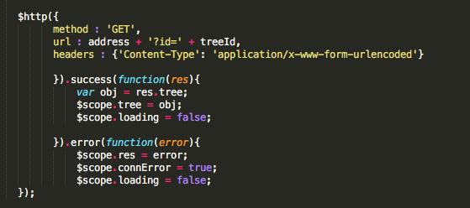

The response in this case:

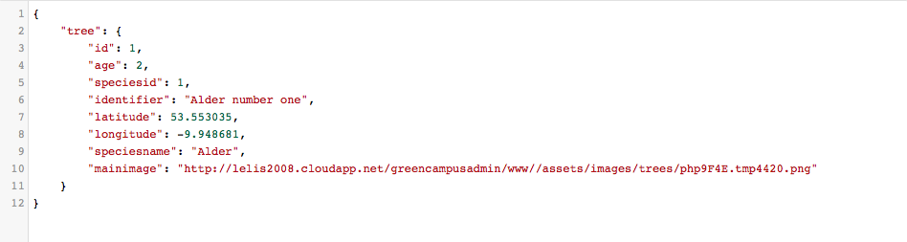

App:

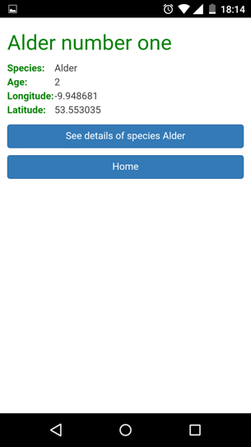

For lists, the services return a array with all the objects requested.

For example:

<http://lelis2008.cloudapp.net/greencampusadmin/www/services/tree.php>

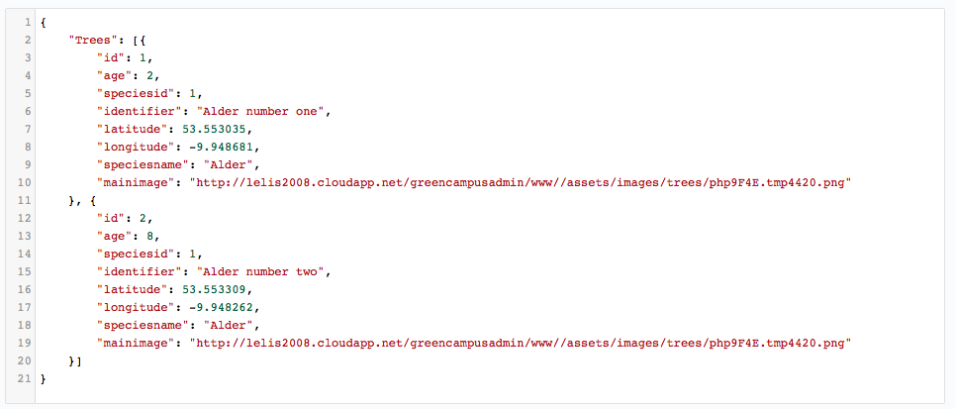

App:

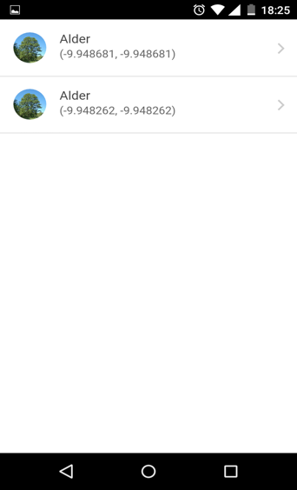

# Class diagram and Data Model

The Data Model for this solution:

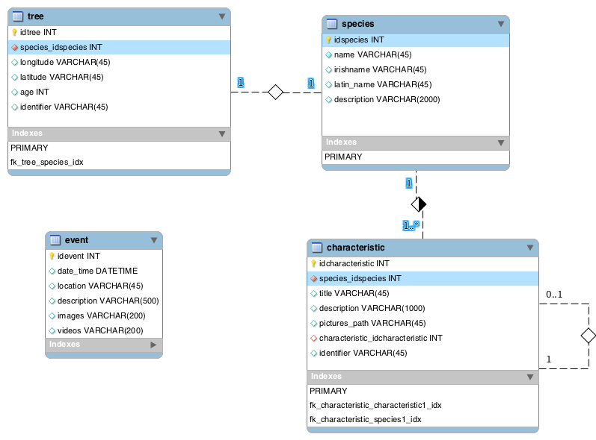

This model was designed with the intention to be as flexible as possible and whose mapped class diagram was fully object oriented. Creating this schema where a species has *n* characteristics (which can have sub-characteristics), I tried to model where any species could fit properly without changes on the database.

Then, in resume:

Tree –(1)-(belongs to)-(1) -> a species;

Species –(1)-has(n)-> characteristics;

Characteristics –(1)-(can have)-(1)->Parent characteristic;

Events;

# Technologies used

As PHP and Ionic are not strongly related to any IDE, I have used a mix of technologies during this process:

* **General PHP, JavaScript, HTML and Angular coding: Sublime Text:**

Easy and light, to write in different languages on the same project. Basic but efficient navigation between files.

* **Ionic (build, run, test on server): command line on Terminal.**
* **Ionic (emulate iOS version): XCode**

You can run a app on emulator from Terminal, but you must have XCode installed to do it. And if you need deploy this on a device, will need a license from Apple.

* **Git: command line on Terminal (local) and GitBash (server)**

There are a few tools to work with Git, but all can be done directly on command line.

* **Database (used to design the model): MySQL/MySQLWorkbench**

MySQLWorkbench is a database tool which shows itself good to design models and extract SQL script from them.

* **Database (running on server): MySQL/PhpMyAdmin**

On server side, Phpmyadmin just to run those scripts and explore table contents.

* **Hosting**

Apache (with Wamp on server).

* **Access to host on MS Azure**

Microsoft Remote Desktop.

# Problems Encountered/Solved

As I had never worked with Ionic or even Angular I was expecting any beginner failure, and it came. While JQuery seems work fine with Ionic when debugging on browser, this combination fails when deployed on android and figure this out took a time. By the way, the solving a problem was a more complex task when it just occurred on the device. We don’t have any debugging tool anymore and became blind to what is happening at the execution time. To solve I just quit using JQuery aside as it was not totally necessary.

That one was the one that cost the most time, but I faced this problem a few more times (mainly on the map) when not everything that works on browser while developing will work after deployed. Or even small differences between iOS and Android like the way they a path to access a internal resource.

I also had planned to use Bootstrap framework, but it was incompatible and I opt to use only its css styles.

# Conclusions

This process was a good experience at the point I trained myself in web services, databases and CRUD operations. Besides that I met and got along with a new framework which I can (and I probably will) use again sometime.

I had worked with mobile apps once by 2012 and it is notable how the technologies developed since then. More powerful hardware, better and more omnipresent internet coverage and a more mature scenario for developers, have made that work a lot more efficient process and made the apps faster and more polished.

Mobile and cloud storage is a trend and this market will keep increasing for a time, letting a vast area of unexplored and potential products and solutions.

# Recommendations

As I had a schedule to work on this app and wouldn’t be possible delivery a completely ready to go product, some features can be implemented later.

First of all, although that is a hybrid app, it doesn’t work on iOS devices since we need a Apple Provisioning Profile to deploy the app outside a emulator or release it on App Store. So, a natural next step would be get this profile.

Other improvement would be keep thumbnail versions of the images, to load it faster on lists.

And on the server side, should be some security step, like a login or something.